Missionaries and Cannibals Proble

AIM:
To write a Python program to solve the Missionaries and Cannibals Problem safely using state-space search.

ALGORITHMS:
1. Start.
2. Initialize the number of missionaries and cannibals on both riverbanks.
3. Place the boat on the starting bank.
4. Move one or two people across the river.
5. Ensure that missionaries are never outnumbered by cannibals where missionaries are present.
6. Repeat until everyone reaches the other bank.
7. Display the solution.
8. Stop.

CODE:
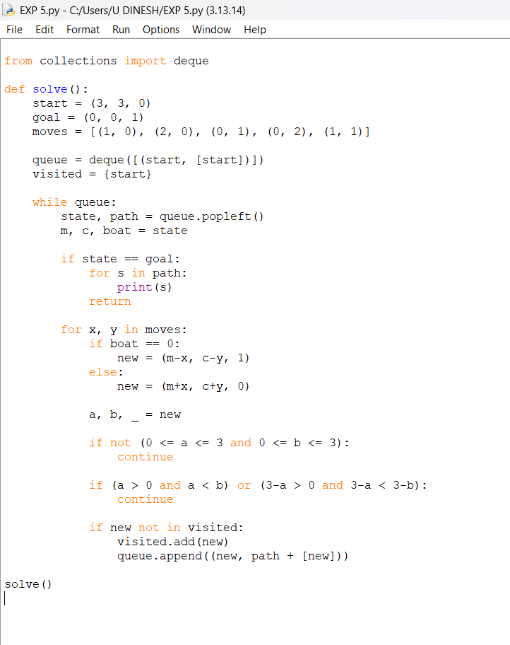

OUTPUT:
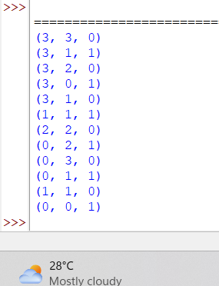

RESULT:
Missionaries and Cannibals Problem: All missionaries and cannibals are safely transported across the river without violating the constraints.

